

**November 25**

**Christmas Parade**

A holiday tradition as New Buffalo brings the magic of Christmas to downtown with a Miracle on Whittaker Street. Enjoy a Santa breakfast, Reindog parade, cookies and hot cider, and tree lighting and caroling. This is a great time to kick off your holiday shopping on Small Business Saturday by shopping at the local businesses in New Buffalo. Times, location: TBA

All day celebration with parade starting at 3:30pm.

Do not forget to visit local venues such as The Silver Creek Event Center at Four Winds Casino or The Acorn Theater in Three Oaks for a variety of shows and entertainment!



Winter Storage Reminders:

Bicycles MUST be removed from the property for the winter. Items that will not fit in the dock boxes are NOT to be stored on the peninsulas over the winter with the exception of grills and ladders. Grills must be secured to the dock box to withstand the brutal winter winds of Lake Michigan.

If you plan on bubbling over the winter, please contact the office for a bubbling registration form ASAP as bubbler installation is beginning**.** A $200 electric deposit is required. The office also has an inspection agreement form for Bob if you are interested. The charge for Bob to check your bubbler and boat daily is $100 for the season.

Seawall ladders and finger pier ladders are the occupant’s responsibility. The deadline for this has since passed. If you plan on doing this yourself and cannot make the deadline, please contact the office ASAP otherwise the maintenance staff will perform the service and you will be invoiced for $30/ladder. If you prefer, you may contact the office to request that maintenance remove your seawall ladder or raise your finger pier ladder for the same fee of $30/ladder.

Please remember that items left on docks are not the responsibility of The Moorings. Please lock up what you leave!

**OFFICE HOURS:**

**We have started our transition into winter hours and will be open the following hours starting November 9th, 2017**

**Monday-Thursday: 9am-5pm**

**Friday: 9am-4pm**

Happy Fall Boaters!

Although Mother Nature gifted us beautiful weather up to the near end of our season, fall was bound to show up. Flip flops and BBQ’s have been traded for hoodies and comfort food as we transition into the winter months. Don’t let the thought of winter get you down because the 2017 Boating Season here at The Moorings was bright and eventful as always. 2017 Saw a host of new faces and boats to our Harbor along with long fun days and memorable evenings. Per usual, The Harbor Country Yacht Club did a fabulous job keeping our bellies full at our Member Cookout, Pancake Breakfast, and annual Hog Roast. E-Dock’s Lobster Fest and D-Dock’s Freedom Fest rocked our Labor Day weekend and New Buffalo’s Ship & Shore Festival and Wine Harvest gave us even more exciting nights to store in the memory book. The Moorings Clubhouse hosted an average of 4 private parties per week and our pool area was one of the hottest spots around. Just because the summer sun has set doesn’t mean that the good times are done though! See the event calendar below to see the many reasons to still visit Southwestern Michigan during the Fall months as well as changes to expect in the coming weeks. The Moorings Board and Staff would like to thank you for making 2017 another successful season. All our staff’s hard work aside, it is truly our Boaters that make this place come alive every spring and we are forever grateful for each and every one of you!

We sent invitations to the Owners and Renters in August. Included you will find a 2018 Occupancy Form for Owners and a 2018 Seasonal Boat Reservation Form for Renters. **These forms are imperative for Management to prepare for the 2018 season.** Please complete and return the form to the office if you have not done so already. We cannot rent a slip without the Owner Occupancy Form on file and all slips not reserved by a renter will be added to the list of rentals available. Owners act NOW to ensure your slip is rented! Renters act NOW to retain the slip that works for you for next season!

**Also, as a reminder, YOU MUST HAVE YOUR CURRENT CERTIFICATE OF INSURANCE TO US PRIOR TO CHECK-IN otherwise you will not be allowed to check in and/or drop your boat. I would highly suggest that as soon as you read this section to contact your insurance agent and request that “The Moorings Association” 310 Oselka Drive, Suite 256, New Buffalo, MI 49117, be added to your policy as an additional insured and request that they automatically send your insurance Certificate each year to the office via email or facsimile (269) 469-4180.** This will save you a lot of time and heartache when your checking in at the beginning of the season.

**Event Calendars**

For additional information please visit the city’s website

St. Joe: [www.stjoetoday.com/all-events](http://www.stjoetoday.com/all-events)

South Haven: [www.southhaven.com/south-haven-events.shtml](http://www.southhaven.com/south-haven-events.shtml)

New Buffalo: [www.newbuffalo.com/events-calendar.shtml](http://www.newbuffalo.com/events-calendar.shtml)

**MOORINGS NEWS**

**E-Dock Electric:**

As you may or may not know, we had an extensive electrical project plague E-Dock this season. We appreciate our Boater’s patience during this messy project and are happy to announce that the E-Dock electric Project of 2017 is complete! Our landscaping company is putting the final touched on the peninsula this week and 2018 will show E-Dock emerge as its usual beautiful self and most importantly will have updated and SAFE electric!

**INSURANCE POLICIES:**

Please be sure to check your **insurance** **policy** **dates** and provide the office with a valid Certificate of Insurance. There are many policies that have expired over the summer and we need to have current insurance information on file. You can fax, mail or email the certificates to us.

**Odds and Ends**

Umbrellas: Please remember that wooden umbrellas are not allowed at The Moorings. Not only do they have a higher risk of breaking in the wind, but they also swell with the wet weather. These are commonly broken trying to remove from the dock box tables.

Email Addresses: Since we are sending the majority of our mailings by email please let us know if we have the correct email address. If you have supplied us with an email but never use it please request that we delete your email address and add you to our mailing list.

Winter Newsletters: Expect monthly newsletters to continue through the winter with additional information regarding our association, Lake Michigan, the surrounding areas, and important notes to help prepare us all for the 2018 Boating Season.

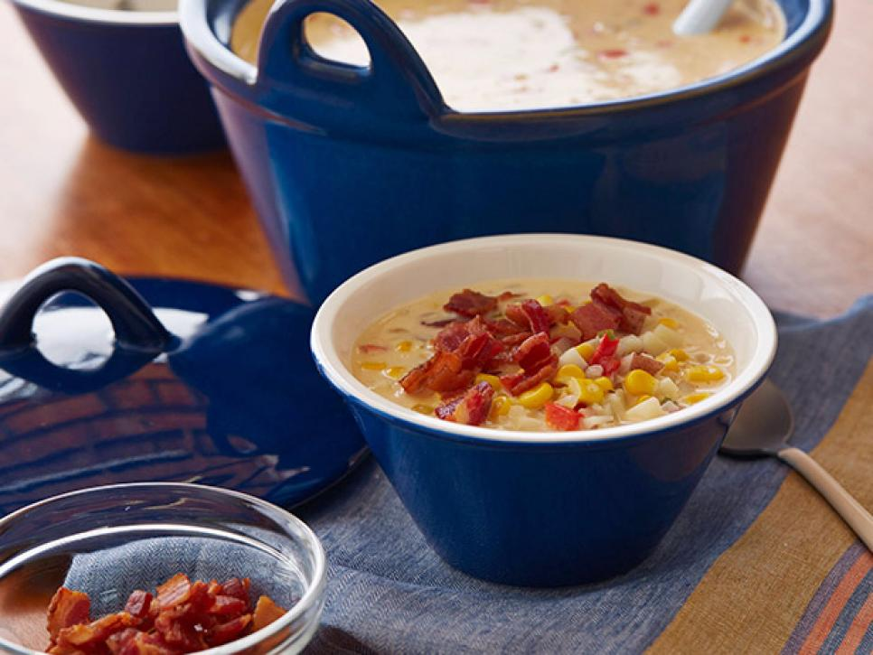

**RECIPE OF THE WEEK:**

Gina’s Spicy Corn Chowder

http://www.foodnetwork.com/recipes/patrick-and-gina-neely/ginas-spicy-corn-chowder-recipe-1948347

**2017 MOORINGS EVENT CALENDAR**

11/1: Marina Shut Down and 2018 Owner AND Renter Forms Due

11/9: The Moorings Office Switches to Winter Hours

11/23-11/27: Office is closed. Happy Thanksgiving to you and yours!

11/25: New Buffalo Santa Parade and Holiday Events

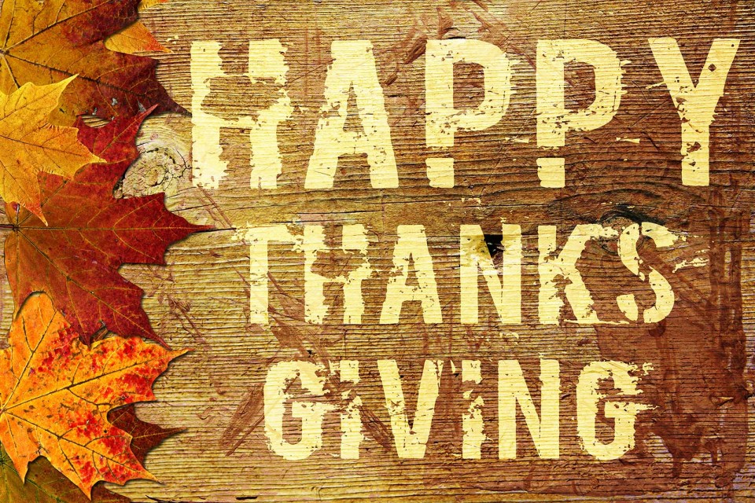

**MOORINGS BOARD OF DIRECTORS**

George Repiscak, President Ron Specht, Vice President

Bob Sorensen, Secretary William Stoll, Treasurer

Ed Jedlicka Don Schuster

Donald Stoneburner

**The Moorings Association**

310 Oselka Drive

New Buffalo, MI

Phone: (269) 469-5790

Cell: (219) 221-7751 (Ashley)

Email: [themoorings@themooringsassociation.com](mailto:themoorings@themooringsassociation.com)

Web: [www.themooringsassociation.com](http://www.themooringsassociation.com)

**COMCAST CABLE:**

For any and all questions about Comcast please contact

**Justin Thompson**

**574-229-9431**. All docks are prewired.